Date:
TASK 5: CNOT Gate and Quantum Teleportation

Aim: To simulate a CNOT gate and implement a simplified quantum teleportation protocol using Qiskit.

Mathematical Model of the CNOT Gate
- The CNOT (Controlled-NOT) gate is a two-qubit quantum gate that flips the target qubit if and only if the control qubit is in state ∣1⟩.
- Computational basis ordering: ∣00⟩,∣01⟩,∣10⟩,∣11⟩ with first qubit = control(q0), second qubit = target(q1).

Matrix Representation
The CNOT gate is represented by the following unitary matrix
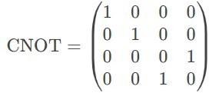

CNOT Gate Truth Table
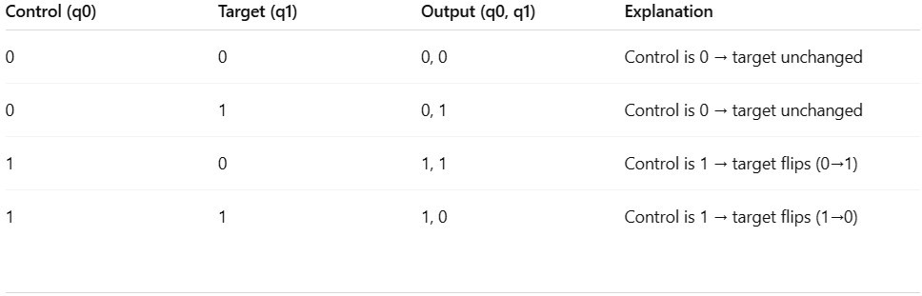

  - Effect on Basis States
    - If control = |0⟩, target remains unchanged.
    - If control = |1⟩, target flips (X-gate applied).

Algorithm for CNOT Gate Implementation
- Initialize a quantum circuit with 2 qubits and 2 classical bits.
- Prepare input states (e.g., test all possible combinations: |00⟩, |01⟩, |10⟩, |11⟩).
- Apply CNOT gate (control qubit = q0, target qubit = q1).
- Measure the qubits and store results in classical bits.
- Simulate the circuit using Qiskit’s Aer simulator.
- Plot the measurement outcomes.

Program
from qiskit import QuantumCircuit from qiskit_aer import Aer
from qiskit.visualization import plot_histogram import matplotlib.pyplot as plt
def cnot_circuit(input_state): """
Creates and simulates a CNOT circuit for a given input state.
Args:
input_state (str): '00', '01', '10', or '11'
"""
qc = QuantumCircuit(2, 2) # 2 qubits, 2 classical bits

# Prepare input state
if input_state[0] == '1': qc.x(0) # Set q0 to |1⟩
if input_state[1] == '1': qc.x(1) # Set q1 to |1⟩
# Apply CNOT (q0=control, q1=target) qc.cx(0, 1)

# Measure qubits qc.measure([0, 1], [0, 1])
# Simulate
simulator = Aer.get_backend('qasm_simulator') result = simulator.run(qc, shots=1000).result() counts = result.get_counts(qc)

# Plot results
print(f"\nCNOT Gate Test | Input: |{input_state}⟩") print("Circuit Diagram:")

print(qc.draw(output='text')) plot_histogram(counts) plt.show()

# Test all possible inputs
for state in ['00', '01', '10', '11']: cnot_circuit(state)

4. Mathematical Model for Quantum Teleportation

Quantum teleportation enables transferring an unknown quantum state from Alice to Bob using:
- Entanglement (shared Bell pair)
- Classical communication (2 bits)
- Quantum operations (CNOT, Hadamard, measurements)

Initial Setup
    - Alice has qubit
    - Alice and Bob share an entangled Bell pair
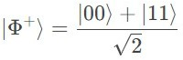

  - Step-by-Step State Evolution

- Combined state
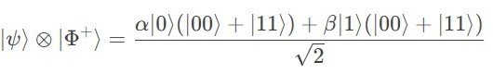
- Alice applies CNOT (q0 → q1)
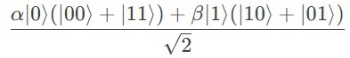

- Alice applies Hadamard to q0

- Alice measures q0 & q1 → gets one of 4 classical outcomes (00, 01, 10, 11)

Bob applies corrections
  - 00: Do nothing
  - 01: Apply X gate
  - 10: Apply Z gate
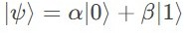
  - 11: Apply X then Z Final state at Bob's qubit

Algorithm for Quantum Teleportation Implementation
  - Initialize 3-qubit circuit (Alice's q0, shared q1, Bob's q2) + 2 classical bits
  - Prepare Alice's qubit (e.g., |1⟩ via X gate)
  - Create Bell pair between q1 & q2 (H + CNOT)

Teleportation protocol
    - CNOT(q0, q1)
    - H(q0)
    - Measure q0 & q1 → store in classical bits

Bob's corrections
    - Apply X if c1=1
    - Apply Z if c0=1

  - Verify by measuring Bob's qubit

Program for Quantum Teleportation Implementation
from qiskit import QuantumCircuit from qiskit_aer import Aer
from qiskit.visualization import plot_histogram import matplotlib.pyplot as plt

# Create circuit
qc = QuantumCircuit(3, 2) # 3 qubits, 2 classical bits

# Step 1: Prepare Alice's state (|1⟩ for demo) qc.x(0) # Comment out to teleport |0⟩ qc.barrier()

# Step 2: Create Bell pair (q1 & q2) qc.h(1)
qc.cx(1, 2) qc.barrier()
# Step 3: Teleportation protocol qc.cx(0, 1)
qc.h(0) qc.barrier()
# Step 4: Measure Alice's qubits qc.measure([0,1], [0,1]) qc.barrier()

# Step 5: Bob's corrections qc.cx(1, 2) # X if c1=1 qc.cz(0, 2) # Z if c0=1

# Step 6: Measure Bob's qubit
qc.measure(2, 0) # Overwrite c0 for verification

# Draw circuit print("Teleportation Circuit:") print(qc.draw(output='text'))
# Simulate
simulator = Aer.get_backend('qasm_simulator') result = simulator.run(qc, shots=1000).result() counts = result.get_counts(qc)
# Results
print("\nMeasurement results:") print(counts) plot_histogram(counts) plt.show()

- Result
This work illustrates the implementation, simulation, and verification of the CNOT gate using Qiskit, followed by the construction of a complete quantum teleportation protocol. The protocol is validated through simulation, confirming the accurate transfer of an arbitrary quantum state using entanglement and classical communication.

